SCHEDULE ‘B’

MASONRY CONTRACT SPECIFICATIONS
The Contractor shall provide all materials, equipment, tools and labour to complete all masonry works including, but not limited to, the following:

- The Contractor shall ensure that he has a competent supervisor on site at all times to ensure all the materials required are supplied and they are properly incorporated into the building structure in a timely manner as construction of the structure proceeds.

- The Contractor shall supply and install all required Brampton brick, or Owner approved equal, as per Owner’s colour selections and drawings.

- The Contractor shall install all required through wall flashing in all areas of brick and stone installation.

- The Contractor shall repair Tyvek Homewrap exterior vapour barrier, where required prior to masonry works- (Tyvek to be installed by others). All Tyvek Homewrap seams and joint repairs to be sealed with approved Tyvek Contractor Tape.

- The Contractor shall supply and install all steel masonry angle iron lintels and brick ties as per the Ontario Building Code and the Owner’s project drawings. Steel lintels shall have even and level bearing and shall have not less than 5 7/8” length of bearing at end supports. All metal ties, fasteners, and flashing shall be corrosion-resistant

- The Contractor shall supply and install contrasting bricks as per the Owner’s drawings and the Owner’s colour selections.

- The Contractor shall supply and install precast sills at all windows and keystones from the Contractors supplier as per the Owner’s architectural drawings.

- The Contractor shall supply all mortar, sand and seal bond as required. Mortar mixes shall not be used later than 2hrs after mixing.

- The Contractor shall provide all scaffolding and hoisting equipment required for his operation and assures that all conforms to all Provincial and Federal safety requirements. The Contractor shall apply protection to all finishing materials, trim, doors and windows, so as to prevent damage and staining of such items by the masonry operations.

- The Contractor shall insure that all masonry work is properly washed/cleaned upon completion. The Contractor shall clean all masonry walls with a solution that is acceptable, and specified by the masonry units’ manufacturer. If Motor is left on brick and Phoenix needs to clean bricks with tint you will be backcharged for the charges

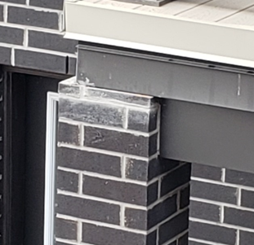 | 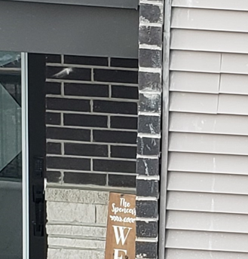

- The Contractor shall provide all labour and tarps for winter protection for a set fee as detailed in Schedule A item # 2. The Contractor shall construct all winter protection for the masonry work on an “as needed” basis. The Owner shall provide propane and heaters, and wood framing materials for hoarding.

- The Contractor shall remove all excess materials and debris etc., from the units to an area as directed by the Site Superintendent.

- The Contractor shall provide a warranty equal to the Owner’s obligations under the Ontario New Home Warranty Program Including a one-year warranty on cracked mortar and two years for water penetration. All work shall conform to Section 9.20 Above grade Masonry of the Ontario Building Code.

- The Contractor shall provide to the Owner, a WSIB certificate of clearance from Worker’s Compensation, confirmation of the legal name for the Contractors’ company, HST number for the company and proof of insurance for the Contractors’ company and completed Registration of Contractors form– all to be provided prior to start of any work on site.

- The Contractor shall insure that all his employees and/or agents comply with the Owner’s Safety Policy and Worker’s Compensation regulations while working on the Owner’s sites.

- The Contractor shall provide an updated Form 1000.

