SCHEDULE B
SCOPE OF WORK - TYVEK

- Contractor shall supply and install approved Tyvek air barrier complete with approved Tyvek tape covering the complete building. This work is to be carried out and completed prior to masonry & siding installation.

- Contractor shall ensure to seal the perimeter of all windows and doors with approved straight wrap tape. Flex wrap tape to be used on all curved windows. Use of red tape is not permitted.

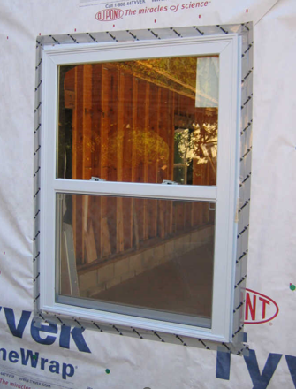

- Contractor shall ensure to overlap and cover all seams, electrical/mechanical items and other items penetrating the Tyvek barrier.

- Contractor shall ensure entry and patio doors and window openings are taped, all sides above the Tyvek as shown on the drawings, and provide a mock-up of each of the following for the Site Superintendent and or Construction Manager to review prior to finishing of the remainder of the scope;
  - Entry Door
  - Patio Door
  - Stairwell Window
  - Unit Windows

- Contactor shall ensure that the Manufacturers installation procedures and methods are followed, and all work complies with the most recent Ontario Building Code including section 9.25.

- Contractor shall meet with the Site Supervisor prior to the commencement of work to inspect existing conditions. Contractor shall report to the site superintended any discrepancies which could affect the quality or scope of building wrap installation.

- Contractor shall include the use of a lift for the installation of the building wrap system and will not install Tyvek from a ladder only if proper access is available.

- Contractor shall follow the Owners Drawings, Site Superintendent and Construction Managers instructions regarding the installation of flashing under all methods of egress.

- The Contractor shall provide to the Owner, prior to starting his work, proof of a Two Million Dollar Liability Insurance naming the Contractor and the Owner jointly for the duration of the contract.

- The Contractor shall remove all waste materials generated by his employees and agents from the surroundings to containers as directed by the Site Superintendent. Should the Contractor fail to remove debris and leave the work site clean, then the Owner shall remove the debris and back-charge the Contractor the entire costs of the clean-up.

- The Contractor shall take all means necessary to ensure his employees and agents comply with all requirements of the Ontario Health and Safety Act and the Owner’s Safety Policy Statement.

- The Contractor shall provide, upon demand, to the Owner, a Certificate of Clearance from Workers Compensation.

- The Contractor shall provide, to the Owner, a warrantee on labour and materials equal to the Owner’s obligations under the Ontario New Home Warranty Program. The Contractor shall warrant that his trades people will take all necessary precautions to prevent the damage of the Owner’s property and the workmanship of any trades people before him.

