SCHEDULE B

Electrical Contract Specifications

The Contractor shall provide all materials, equipment, tools and labour to do complete electric job, including but not limited to the following;

- All works are to be completed by the Contractor as per lot specific drawings, construction summary issued, the project construction schedule, current Ontario Building Code and all other authorities having jurisdiction.

- The Contractor shall report to the Owner any errors or omissions on the drawings prior to proceeding with the work.

- Contractor has visited the site, reviewed the project drawings and is aware of site constraints relating to completion of these works. The lot specific drawings show extent of various building materials and locations.
If there is any conflict in the contract documents, the order of priority shall be contract, specifications, drawings, then other written documents. Furthermore the following conflict rules shall apply:
-specifications shall prevail over general conditions;
-supplementary conditions shall prevail over general conditions;
-figured dimensions shall prevail over scaled dimensions on the same drawing; and
-larger scale drawings shall prevail over smaller scale drawings of the same date

- The Contractor shall ensure that he has a competent supervisor on site at all times to ensure all the materials required are supplied and they are properly incorporated into the building structure in a timely manner as construction of the house proceeds.

- The Contractor shall supply and install a 100amp or 200amp underground service per schedule A located as per Ottawa Hydro, or ESA direction.

- The Contractor shall provide wiring for Decora plugs and switches as per the working drawings and in accordance with the requirements of Ottawa Hydro, and the Electrical Safety Authority, white plugs, switches and lamp holders in basement and dining room. All outlets to be arc fault as required by code.

- The Contractor shall provide wiring for the following equipment: refrigerator, stove, dishwasher, microwave and dryer, furnace/hot water tank, HRV, garage overhead door operator and bathroom exhaust fans.

- The Contractor shall supply and install a 30” ducted kitchen fan (duct by others).

- The Contractor shall supply and install ¾” under slab conduit for bell and cable where applicable.

- The Contractor shall supply and install wiring, bell and transformer for door chime. 1x Push button at front entrance

- The Contractor shall supply and install an approved visual smoke detector (one in each bedroom) and one carbon monoxide detector on the bedroom floor and arch fault breakers as required as well as all required Ground Fault Circuit Interrupters.

- The Contractor shall supply and install powder room and bathroom fans (ducts by others).

- The Contractor shall supply and install light fixtures in all bedrooms. See light fixture schedule.

- The Contractor shall supply and install two (2) exterior W.P. plugs on G.F.C.I. All kitchen and vanity countertop plugs on G.F.C.I. Contractor to install at rough in stage live plugs for use by trades at rear patio door, garage, kitchen, powder room, master bedroom, and furnace.

- The Contractor shall supply and install garage overhead door plug.

- The Contractor shall supply and install wiring for direct vent hot water heater exhaust fan.

- The Contractor shall supply and install wiring for gas fired furnace as well as thermostat wiring (5 wires).

- The Contractor shall supply and install all electrical fixtures, pewter interior and black exterior in color as per attached schedule “C”.

- For the Craftsman series homes the Contractor shall supply and install on the exterior the SAN-A7010-6 light fixtures with a bulb A19 LED type 61 bulb as seen below.

- The Contractor shall be responsible for all costs and administration to acquire Hydro & ESA permits, inspections and approvals as required.

- The Contractor shall supply and install wiring for gas fired furnace as well as thermostat wiring (5 wires). Contractor to Hardwire fireplace igniter and door chimes at front door and main floor patio door. Transformer to be in the same location as the electrical panel.

- Contractor to verify Bathroom vanity light height and location with site superintendent.

- Contractor to install 2 USB/120 charger/plug combination receptacles. One on island and one in kitchen backsplash.

- The Contractor warrants that all methods and materials provided by his forces shall be equal to or better than the Ontario Building Code requirements.

- The Contractor shall endeavor to provide a clean and safe workplace during his operation in accordance with the requirements of Worker’s Compensation and the Owner’s Safety Policy. Install and maintain all required safety barricades, ladders and railings and temporary bracing during the framing stage.

- The Contractor shall place all waste materials generated by his forces in one area as designated by the Owner. Should the Contractor fail to do so, the Owner shall clean the Contractor’s debris and the Owner shall back charge the entire costs to Contractor.

- The Contractor shall carry a minimum liability insurance of Two Million Dollars while on the Owner’s site. This policy shall name jointly the Owner and Contractor for coverage. Confirmation of this policy must be submitted to the Owner before work is to commence.

- The Contractor shall provide to the Owner, a WSIB certificate of clearance from Worker’s Compensation, confirmation of the legal name for the Contractors’ company, HST number for the company and proof of insurance for the Contractors’ company – all to be provided prior to start of any work on site.

- The Contractor will complete the attached registration of Contractors form and return to Phoenix prior to start of any work on site.

- The Contractor or his agent shall be available for meetings with ESA inspectors and the Owner, if required.

- 4 potlights in the kitchen on existing switch (This spec will remove the std light fixture(s) and if applicable, fixture over a sink).

- Single Sinks in ensuites.

- Electricians are to put power to second floor at rough in stage whether it be in all bathrooms or somewhere on second floor some kind of working plugs.

If the Phoenix Head Office sends you a client Request for Pricing, Phoenix would expect the pricing to be returned within 48 business hours.

If you do not cancel or reschedule your service appointment with at least 24 hours notice, we may assess a $250.00 “no-show” service backcharge to your account.
Note a Saturday or Sunday notification for a Monday service call is not valid.

Lighting Schedule

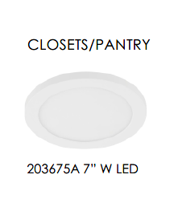 | 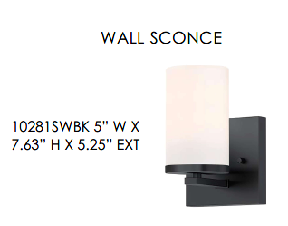 | 
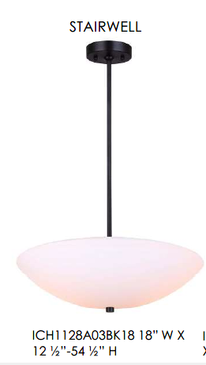 | 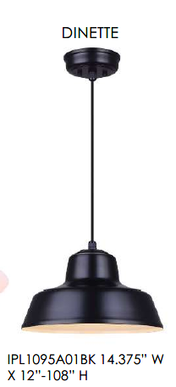
EXTERIOR
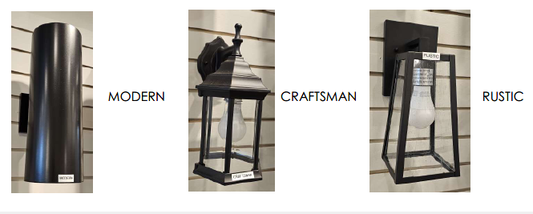
BATHROOMS
52105 BK- for vanities less than 37”
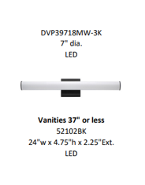
52102 BK for vanities for vanities less than 49”
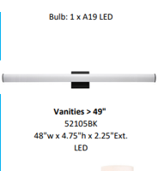
52104BK for vanities over 49”
